Project Stork, Inc.
Jenny Staebell, Founder & Director
August 2018

Condom Access Program

Orleans & Erie County
According to the new data released from the NYS Youth Risk Behavior Survey in 2017, 22.3% of New York ninth through twelfth graders who were currently sexually active 41.4% did not use a condom the last time they had intercourse, this a slight increase from the 2015 survey. (2017 Youth Risk Behavior Survey NYS)  According to the 2015 NYS Department of Health Statistics, Orleans County ranks 11th, and Erie County ranks 13th for the highest total in the number of teen pregnancies ages 15 to 19 years old, out of 57 counties (excluding NYC) in New York State. The data can support that the use of condoms during sexual intercourse is inconsistent. (source NYS Dept. of Health)  Promoting access to condoms in the Orleans and Erie County communities would support our youth and young adults in the prevention of STDs, HIV, and unintended pregnancy. It is important to note, according to studies, giving teens free condoms does not lead to teens having sex more often, but does lead to teens who are already having sex to use condoms more often.  Even though teens and young adults can buy condoms in different places, it is not always easy for teens to get the condoms they need to protect their health and future. Condoms can be too expensive for some teens. It can also be embarrassing to ask for them in a store, and some teens may not know where to find condoms.  When teens enroll in our program they will receive ten condoms, of their choice, and sexual health information, mailed discretely to their home, once a month. This is all done directly from the Project Stork, Inc. website. They can easily enroll online or by calling our office. The information received from participants is solely used for mailing, tracking our demographics, and creating a database of our survey responses. At no time will participant information be shared or used for any other purpose.  Project Stork, Inc. is striving in our surrounding areas to promote sexual health services that are not only welcoming to our counties but also offers access to contraception in free and untraditional ways. It is our mission to increase young people’s knowledge of, and access to, comprehensive reproductive health care resources, free contraception, and information on maintaining a healthy sexual lifestyle that eventually leads to sexually healthy and aware adults. |  |  | Awesome Momma Spotlight  17-year-old Sally is five weeks away from giving birth to her precious baby boy Hudson. This past June she graduated from Medina High School, despite many pregnancy related health problems, she persevered, brought up her attendance and GPA and walked across the staged with her other classmates and graduated. I have not found a more committed young lady; this girl is inquisitive and wants the best for her little Hudson. She is involved with the MOMS Program from UMMC in Batavia and participated in both the Childbirth Classes and Breastfeeding Course, she has taken a tour of the maternity floor, she is an active client of All Babies Cherished, and she attends EVERY monthly Project Stork meeting. You can find us talking about babies over a bagel and soup at Tim Hortons. She hopes to work with foster children in the future. However, right now her focus is Hudson. Dakota, Sally’s Boyfriend and Hudson’s father, is also very excited for the arrival. He is also a Medina Graduate and has a full-time job. A little family to be proud of.
Support Project Stork, Inc. at Oakfield Labor Daze
Please see attached outline of events.
September 1st – 3rd
Located at Triangle Park, Oakfield, NY 14125
http://oakfieldbetterment.com/

Happenings
A Space of Our Own  Project Stork, Inc., over the past six months, has reached out to different buildings, hospitals, old schools, and corporations looking for a donated space or a space at an extremely reasonable cost. Well we have finally found a space that loves our passion and our cause and our story and it is exactly where we wanted to be! In Orleans County, specifically, Albion. We will have an office in the Arnold Gregory Complex. Although there is a VERY small cost associated with this, we feel as if this service will greatly benefit the Orleans County youth that we are assisting in the prevention of teenage pregnancy, STDs, and HIV and this outweighs any building fees in our minds.  In addition to youth being able to obtain information on sexual health, they can also enroll in our programs, participate in 17 Days, and acquire FREE contraception between the hours of 7am – 5pm. This is a perfect service for students walking to and from school. And finally, a space for meeting with young parents to discuss goals, educational plans, career outlooks, and parenting skills.  I couldn’t be any more excited to setup Ellie’s Friendship Closet! Where teen parents can shop new and VERY gently used clothing up to 3T. A perfect location, since Ellie’s momma, who is a Dental Hygienist also works in this complex. Funny how things work out! I am honored to help in a small way to carry Ellie’s memory through my work and share her story.  In Loving Memory of Ellie Rush  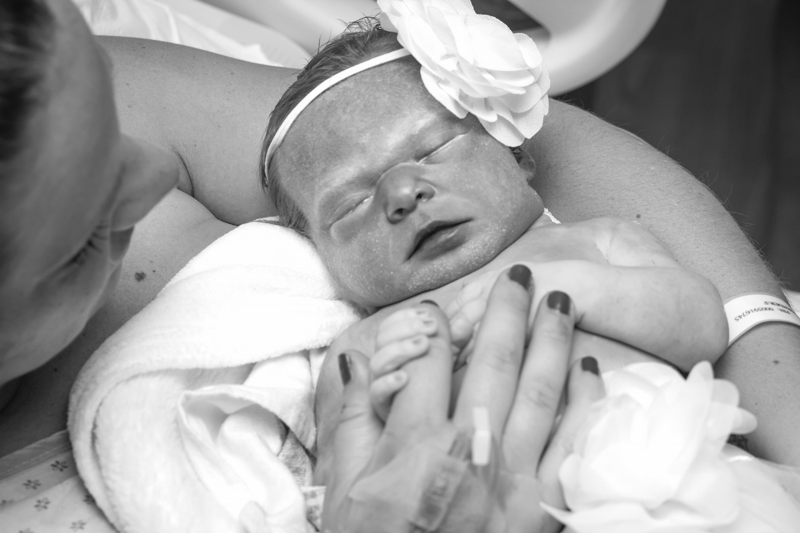  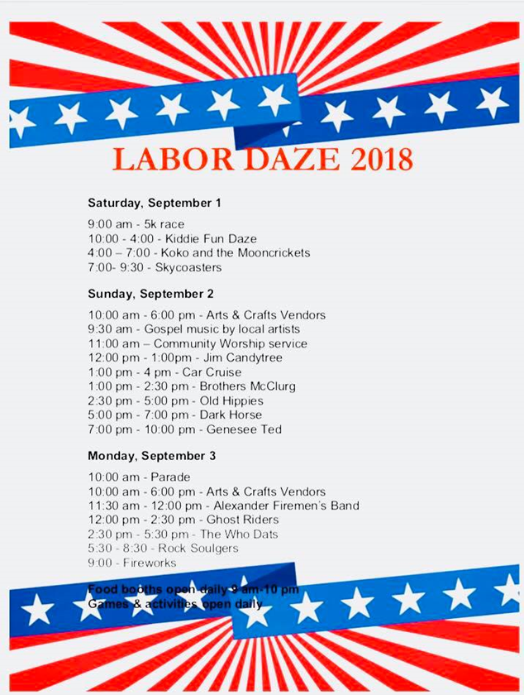 |  | Sponsorships  As an organization, we grow and depend on the generosity of yearly sponsors, memberships, and donors. We continuously look for businesses that support and can become invested with our mission. If you are interested in becoming a sponsor or know of a person or business please share our information.  Please visit:  https://www.projectstorkinc.org/sponsorship  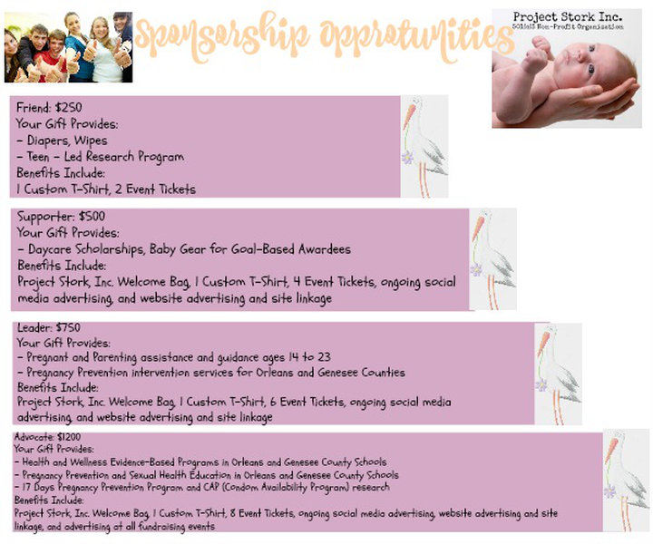  https://www.facebook.com/projectstorkinc/

